**Healthcare Monitoring and Management System**

**Indrashis Mitra, Kinjal Sarkar, Pratyay Basu and Souvik Karmakar**

**Guided by: Dr.** [**Kananbala Ray**](mailto:kbrayfet@kiit.ac.in)

***Abstract -*** In today’s population aging scenarios in the developing countries, there is an epidemiological and demographic transition which is affecting the health state of the entire population. Healthcare sectors have boosted immensely in terms of science, technology and services in the recent few decades. The next big change that is to skyrocket this field in terms of quality, efficiency and quantity is the introduction of ‘Automation’ in these sectors. With the assistance of IOMT we are targeting a large part of the population to get the diagnosis readily available at cheaper rates even when some medical professional is absent. Data by various metrics monitoring sensors are sent to the cloud via a Wi-Fi module and then displayed remotely which assures saving of the crucial golden hours of the patient. Now patients themselves can monitor their health parameters, sitting at home which will increase the efficiency of the healthcare sectors and industries. Overall by implementing this technology in the near future people can effectively reduce the hassling circumstances and not only unlock but also boost the true potential of the healthcare systems which ultimately will be a boon to mankind.

***Index Terms -*** Temperature,IOT,Android,Microcontroller,ESP8266 Wi-Fi Module,IFTTT

1. INTRODUCTION

The Internet of things is used to interconnect devices, apps,sensors and network connectivity that enhances these entities to gather and exchange data. IOT has distinguished characteristics which are very helpful in the healthcare domain to constantly monitor patients.It is possible to check various parameters recorded by different types of sensors and infer results from their time varying nature. There are quite a few problems in the healthcare domain such as delay in alerting doctors in an emergency situation of a continuously monitored patient, hindrances in consultation and sharing information with specialists ,family members and relatives,to name a few. The technology that solves these problems is already available but not accessible and affordable by most of the people. Hence solutions to these problems can be just a simple extension to the current devices which don’t have these facilities.

In this project we have designed a system to continuously monitor vital parameters such as heart rate and body temperature. The information is stored on a cloud server database uploaded by Node MCU and can be displayed through an online dashboard or mobile application to authorized personnel only. The main objective of this system is to update the data online and send an alert to the doctors for any abnormality so that serious patients can receive treatment on time. In addition to this we have worked on a mechanism to detect and alert caretakers if an elderly person accidentally falls down,so that they receive help on time.

1. LITERATURE REVIEW

The authors proposed a health monitoring system that monitors the heart rate and temperature of the patients along with some environmental parameters that are measured by room-temperature sensor, CO sensor and CO2 sensor. The acquired data is transmitted over wireless networks, maintained in a single database of patients, giving an alert to the authorities, aside from personalization of critical health-related criteria. The verified medical team collects the raw data, analyzes, makes and makes decisions virtually using the data, without meeting in person.

Authors have done a comprehensive study on the recent advancements in IoT-based healthcare technologies, the IoT network architectures/platforms, applications, and industrial trends. They have also analyzed several other IoT security and privacy features,which includes threat models, security requirements and attack taxonomies, when taken from the perspective of the healthcare industry. Further, to face the challenges for future research on IoT based healthcare, they have proposed a smart collaborative security model that considerably lessens security risk; explains how innovations like big data, Machine learning, ambient intelligence, and wearables technology that can be leveraged in a health care context.

The authors proposed a system that effectively monitors pulse rate in real time. The sensor, connected to the Microcontroller in Arduino UNO acts as a data source which is acquired by the sensor node. Then this data is pre-processed and labelled. This can then be relayed to the cloud/database(ThingSpeak) for the additional scope of appropriation in data analysis. This data is taken to observe the parameters for the future observation, predictions etc.

1. BASIC CONCEPTS

**Embedded Systems**: Embedded systems have long been part of the development of medical devices . Our main objective in this project is to ensure patients get ample attention regarding their health which sometimes becomes difficult when the patient stays at home . Also in this Covid scenario where the hospitals are already overwhelmed with covid patients it will be easy for patients as well as doctors if they can monitor the patients from their home itself .

As a result we have divided this project into two specific parts -

1. **Health monitoring system** - In this part of the project we monitor the temperature and the pulse of the patient. We use MLX 90614 for temperature measurement and MAX 30102 for pulse monitoring of the patient. Keeping in mind the recent Covid scenario, if the patient has a high temperature then it will automatically be shown on the online dashboard, where the doctors can get the data of the patient. Same goes for the pulse sensor if the pulse becomes too low or high then the doctors or the family members of the patient can monitor it too. We designed a small wearable module where both the temperature and the pulse rate will be displayed. This module is also used for fall detection.
2. **Fall Detection system** - Fall Detection is really important for elderly people where falling and not getting up can be fatal sometimes. To minimize that we used an MPU6050 module which helps us to detect a fall using an accelerometer and gyroscope. The sensor will be inside the wearable and will send message notifications to the family members or the number that will be registered. Within a designated time if the person is not picked up the message will be sent again.

**Internet of Things (IOT)** : The core area of ideation was to display the data collected by the sensors in an interesting and understandable way, for which we intend to use 2 platforms - website and mobile application. For the website we plan to build a dashboard using thinger.io, which is a free, open-source cloud IOT platform that has a variety of features to make effective and easily manageable dashboards. By specifying the various connections and widgets, we intend to build a dashboard as shown in the fig. This is done so that the parameters can be monitored whether they remain in the threshold limits and a generic person can also understand the fluctuations in the measured values by viewing the graphical representation of the measured values on the dashboard.

Blynk was originally developed for the Internet of Things. It can control hardware remotely, it can display sensor data, can store and visualize data and is useful for various other purposes. The parameters that are being monitored by the different sensors are visualized remotely via the Blynk app. This allows a quality GUI experience for the customers i.e. the relatives and family members of the patient. By using the Blynk app anyone who is shared with the QR code can download the app and it will contain the required project for metrics monitoring. This approach will reduce the amount of panic within family members and will provide a suitable environment and time duration for the best possible treatment of the patient.

IV. IMPLEMENTATION AND RESULTS

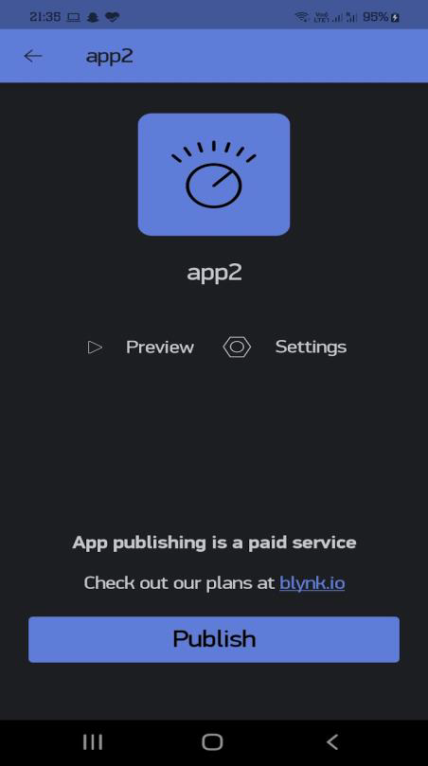 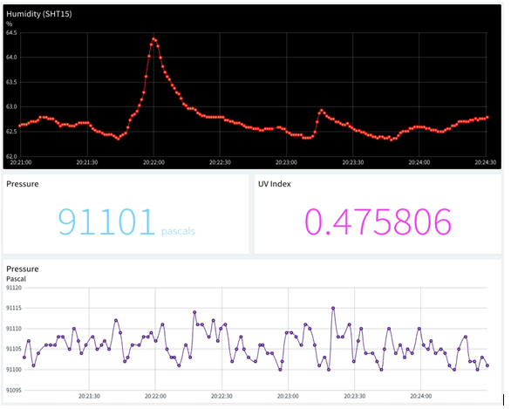

*Fig - Visual representation of dashboard and blynk app*

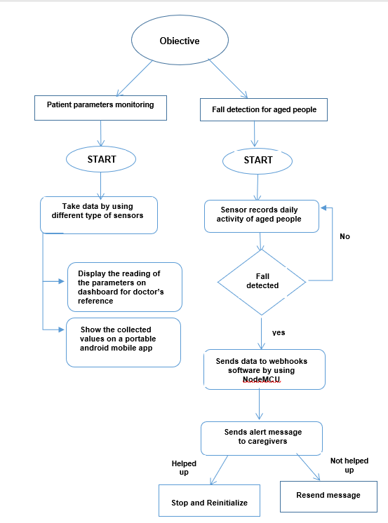

*Fig . - Flow diagram*

1. CONCLUSION

The objective of this Project is to overcome the problems which may reduce the problems faced by patients and those in need of urgent medical help and attention,in troublesome times like the present scenario of the pandemic. Here we have mainly focused on two objectives- one is a health monitoring system, used to collect the health history of patients with a unique ID and store it in a database. Doctors do not need to spend much time searching the reports and give their analysis simply by referring to the dashboard. Any ongoing treatment will be automatically updated on the dashboard. The other one is the Wearable-Sensor-Based Fall Detection System for aged people to monitor their movements and recognize if they accidentally fall down . This is done by using sensors and automatically an alert for help is sent to the caregivers so that they can come to their aid.

REFERENCES

[1]. Md. Milon Islam, Ashikur Rahaman and Md. Rashedul Islam. 2020. Development of Smart Healthcare Monitoring System in IOT Environment *Springer Nature Singapore Pte Ltd*.

[2]. Riazul Islam SM, Kwak Daehan, Humaun Kabir M, Hossain M, Kwak Kyung-Sup. The Internet of Things for health care: a comprehensive survey. *IEEE Access. 2015;3:678–708*

[3]. Hari Kishore K, Surendra Nath K V, Hari Krishna K V N, Pavan Kumar D, Manikanta V and Fazal Noor Basha. 2019. IOT Based Smart Health Monitoring Alert Device *International Journal of Innovative Technology and Exploring Engineering* 8

[4]. Deepak N, Rajendra Prasad C H and Sanjay Kumar Ch. 2018. Patient Health Monitoring using IOT *International Journal of Innovative Technology and Exploring Engineering* 8.

[5]. Tamilselvi V, Sribalaji S, Vigneshwaran P, Vinu P, GeethaRamani J. IoT based health monitoring system. In: 2020 6th International conference on advanced computing and communication systems (ICACCS). IEEE; 2020. p. 386–9

[6]. Prakash H Patil, Pratyush Singh, Swatee Biradar and Prasad Rane. 2013. Design and Implementation of Wireless Patient Health Monitoring System *International Journal of Engineering Research and Technology 2* (6).

[7]. Rahaman A, Islam M, Islam M, Sadi M, Nooruddin S. Developing IoT based smart health monitoring systems: a review. *Rev Intell Artif. 2019;33:435–440. doi: 10.18280/ria.330605.*

[8]. Islam M S, Islam M T, Ali F. Almutairi, GankokBeng, Amid N M N. 2019. Monitoring of the Human Body Signal through the Internet of Things (IoT) Based LoRa Wireless Network *System Journal of Applied Sciences 9*

[9]. Desai MR, Toravi S. A smart sensor interface for smart homes and heart beat monitoring using WSN in IoT environment. *In: 2017 International conference on current trends in computer, electrical, electronics and communication (CTCEEC). IEEE; 2017. p. 74–7*

Monitoring System